**NAME: Om Muddebihal**

**SAP ID: 86092300033**

**ROLL NO: A032**

**Practical 1: Infrastructure as a Service using AWS**

**Cloud Computing Architecture:**

As we know, cloud computing technology is used by both small and large organizations to store the information in cloud and access it from anywhere at any time using the internet connection.

Cloud computing architecture is a combination of service-oriented architecture and event-driven architecture.

Cloud computing architecture is divided into the following two parts -

**Front End**

**Back End**

**The below diagram shows the architecture of cloud computing -**

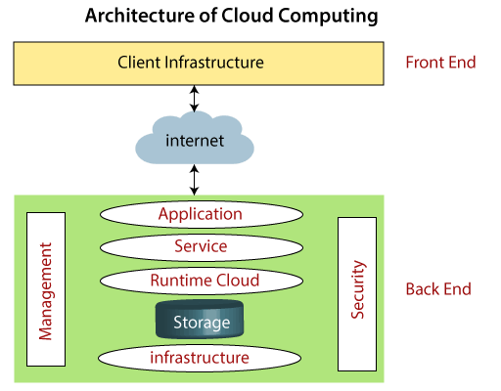

**Front End**

The front end is used by the client. It contains client-side interfaces and applications that are required to access the cloud computing platforms. The front end includes web servers (including Chrome, Firefox, internet explorer, etc.), thin & fat clients, tablets, and mobile devices.

**Back End**

The back end is used by the service provider. It manages all the resources that are required to provide cloud computing services. It includes a huge amount of data storage, security mechanism, virtual machines, deploying models, servers, traffic control mechanisms, etc.

Both front end and back end are connected to others through a network, generally using the internet connection.

**Components of Cloud Computing Architecture**

There are the following components of cloud computing architecture -

**1. Client Infrastructure**

Client Infrastructure is a Front end component**. It provides GUI (Graphical User Interface) to interact with the cloud.**

**2. Application**

The application may be any software or platform that a client wants to access.

**3. Service**

A Cloud Services manages that which type of service you access according to the client’s requirement.

Cloud computing offers the following three type of services:

**i. Software as a Service (SaaS)** – It is also known as cloud application services. Mostly, SaaS applications run directly through the web browser means we do not require to download and install these applications. Some important example of SaaS is given below –

Example: Google Apps, Salesforce Dropbox, Slack, Hubspot, Cisco WebEx.

**ii. Platform as a Service (PaaS) –** It is also known as cloud platform services. It is quite similar to SaaS, but the difference is that PaaS provides a platform for software creation, but using SaaS, we can access software over the internet without the need of any platform.

Example: Windows Azure, Force.com, Magento Commerce Cloud, OpenShift.

**iii. Infrastructure as a Service (IaaS) –** It is also known as cloud infrastructure services. It is responsible for managing applications data, middleware, and runtime environments.

Example: Amazon Web Services (AWS) EC2, Google Compute Engine (GCE), Cisco Metapod.

**4. Runtime Cloud**

Runtime Cloud provides the execution and runtime environment to the virtual machines.

**5. Storage**

Storage is one of the most important components of cloud computing. It provides a huge amount of storage capacity in the cloud to store and manage data.

**6. Infrastructure**

It provides services on the host level, application level, and network level. Cloud infrastructure includes hardware and software components such as servers, storage, network devices, virtualization software, and other storage resources that are needed to support the cloud computing model.

**7. Management**

Management is used to manage components such as application, service, runtime cloud, storage, infrastructure, and other security issues in the backend and establish coordination between them.

**8. Security**

Security is an in-built back end component of cloud computing. It implements a security mechanism in the back end.

**9. Internet**

The Internet is medium through which front end and back end can interact and communicate with each other.

**IASS:**

Infrastructure as a service (IaaS) is the on-demand availability of highly scalable computing resources as services over the internet. It eliminates the need for enterprises to procure, configure, or manage infrastructure themselves, and they only pay for what they use.

IaaS in cloud computing is when you rent access to cloud infrastructure resources as individual services from a cloud service provider (CSP), including servers, virtual machines, networking resources, and storage. IaaS helps eliminate much of the complexity and costs associated with building and maintaining physical infrastructure in an on-premises data centre.

The CSP is responsible for managing and maintaining the infrastructure, so you can concentrate on installing, configuring, and managing software and keeping your data secure. IaaS providers also offer additional services, such as detailed billing management, logging, monitoring, storage resiliency, and security.

You can access IaaS resources using a pay-as-you-go basis, allowing you to only pay to consume the resources that you need. In other words, you can easily increase or decrease resources, allowing you to pay less when needed or instantly provision and scale out resources to meet new demand.

**AWS:**

AWS stands for Amazon Web Services, It is an expanded cloud computing platform provided by Amazon Company. AWS provides a wide range of services with a pay-as-per-use pricing model over the Internet such as Storage, Computing power, Databases, Machine Learning services, and much more. AWS facilitates for both businesses and individual users with effectively hosting the applications, storing the data securely, and making use of a wide variety of tools and services improving management flexibility for IT resources.

AWS comes up with its own network infrastructure on establishing the datacentres in different regions mostly all over the world. Its global Infrastructure acts as a backbone for operations and services provided by AWS. It facilitates the users on creating secure environments using Amazon VPCs (Virtual Private Clouds). Essential services like Amazon EC2 and Amazon S3 for utilizing the compute and storage service with elastic scaling. It supports the dynamic scaling of the applications with the services such as Auto Scaling and Elastic Load Balancing (AWS ELB). It provides a good user-friendly AWS Management Console facilitating seamless configuration and management of AWS services to the Users. Its Architecture ensures high availability, fault tolerance making AWS as a versatile powerful Cloud Computing Platform.

The following are the some of the main fundamentals of AWS:

**Regions**: AWS provide the services with respective division of regions. The regions are divided based on geographical areas/locations and will establish data centres. Based on need and traffic of users, the scale of data centres is depended to facilitate users with low-latencies of services.

**Availability** **Zones (AZ):** To prevent the Data centres for the Natural Calamities or any other disasters. The Datacentres are established as sub sections with isolated locations to enhance fault tolerance and disaster recovery management.

**Global Network Infrastructure**: AWS ensures the reliability and scalability of services through setting up its own AWS Network Infrastructure globally. It helps in better management of data transmissions for optimized performance and security reliance.

**Top AWS Services**

In the rapid revolution of Cloud Computing, AWS facilitates with wide variety of services respect to the fields and needs. The following are the top AWS services that are in wide usage:

**Amazon EC2(Elastic Compute Cloud)**: It provides the Scalable computing power via cloud allowing the users to run applications and manage the workloads over their remotely.

**Amazon S3 (Simple Storage Service):** It offers scalable object Storage as a Service with high durability for storing and retrieving any amount of data.

**AWS Lambda**: It is a service in Serverless Architecture with Function as a Service facilitating serverless computing i.e., running the code on response to the events, the background environment management of servers is handled by aws automatically. It helps the developers to completely focus on the logic of code build.

**Amazon RDS (Relational Database Service):** This is an aws service that simplifies the management of database providing high available relational databases in the cloud.

**Amazon VPC (Virtual Private Cloud):** It enables the users to create isolated networks with option of public and private expose within the AWS cloud, providing safe and adaptable configurations of their resources.

1. **Implement Windows Machine using AWS EC2.**

Go to aws.amazon.com and Sign Up by providing all the information.

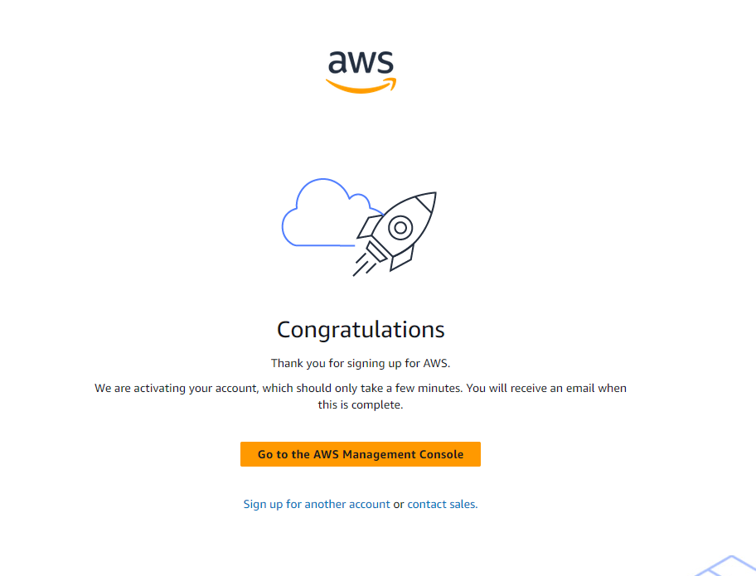

After signing in, Login and go to EC2 Service

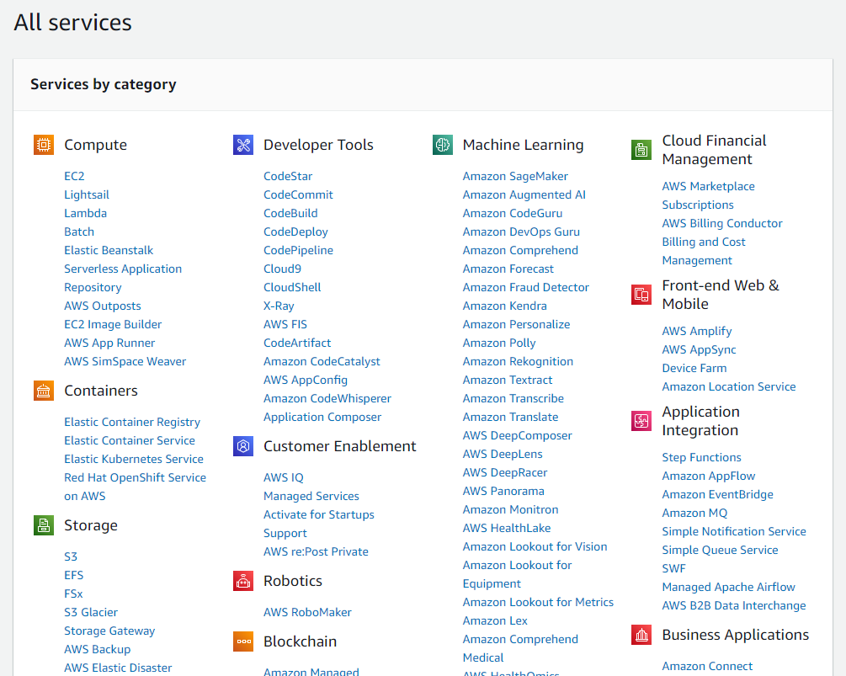

On the left side bar, click on Instances

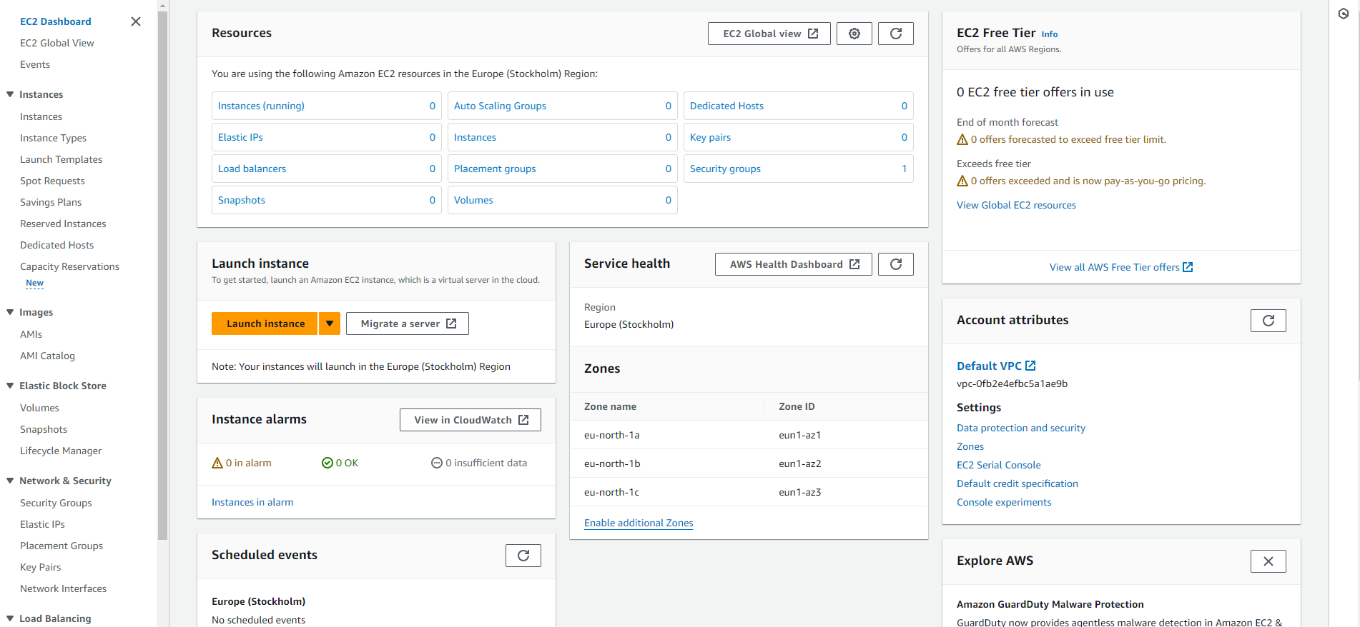

Now click on Launch Instance:

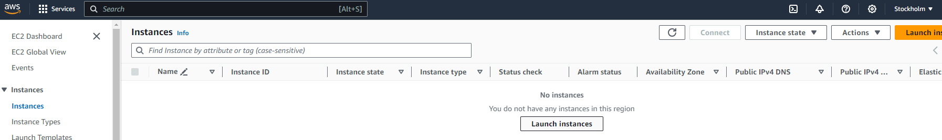

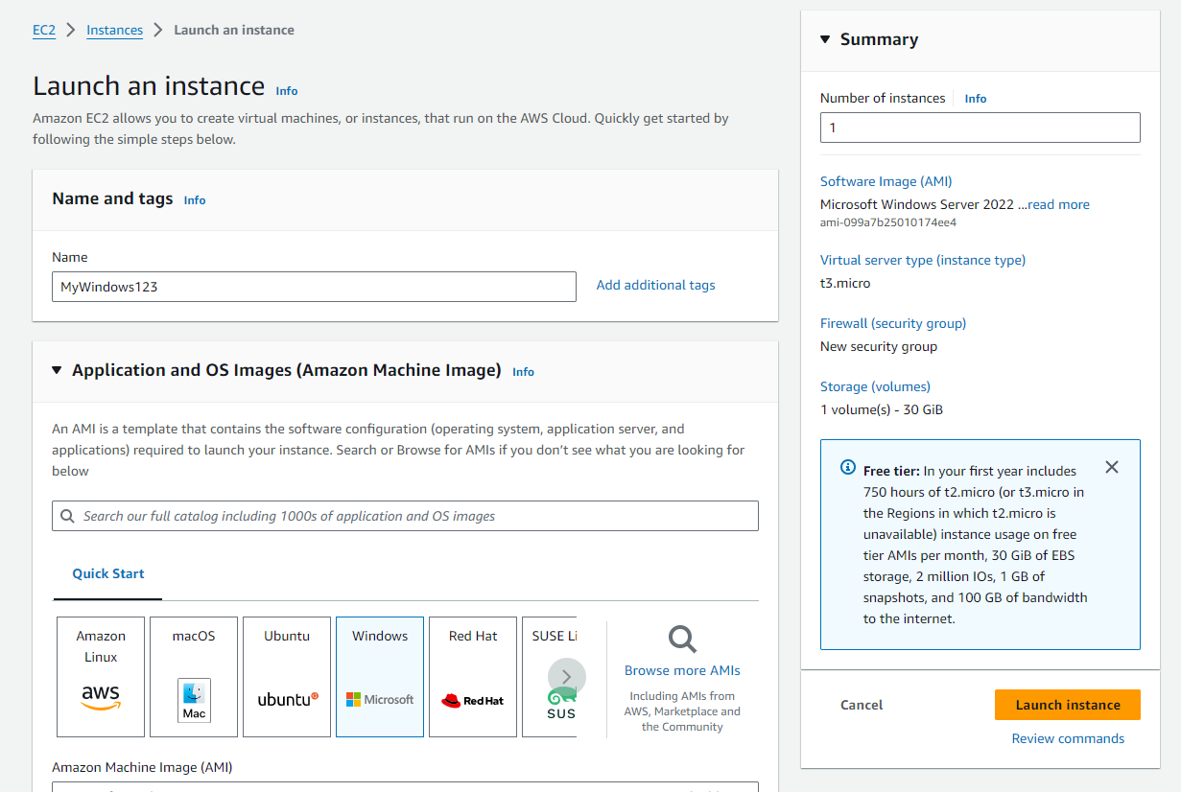

Create a New Key Pair (.pem format)

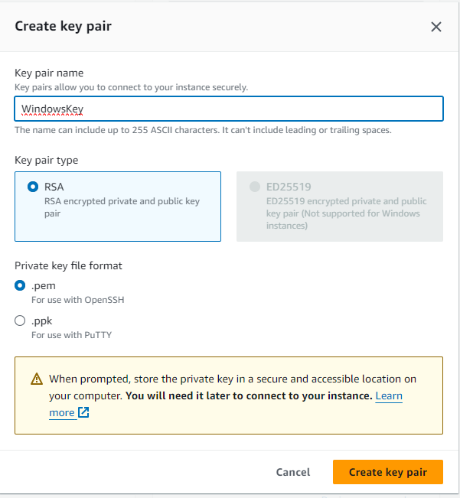

After successfully launching instance, you shall see following message.

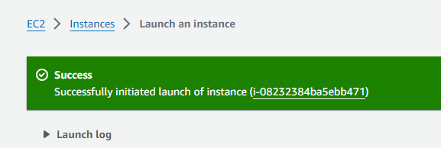

Now select the instance and click on connect.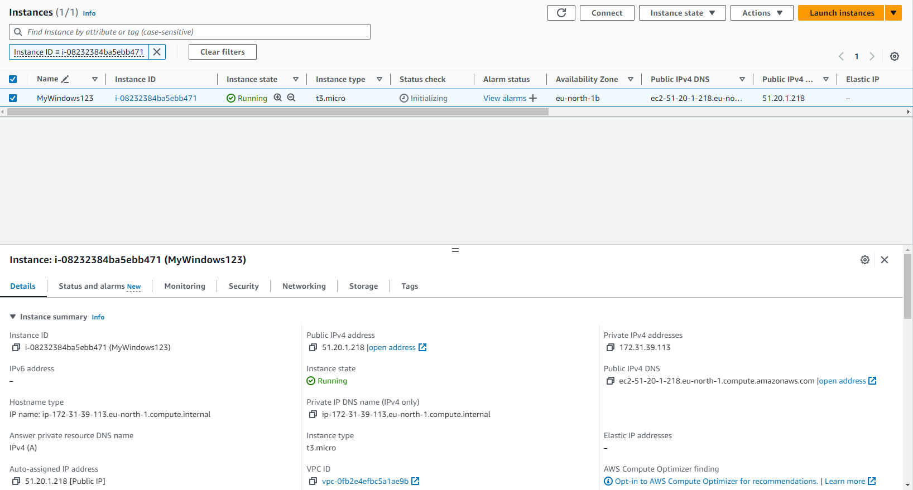

Now, Click on RDP client and click on Get Password also download remote desktop file.

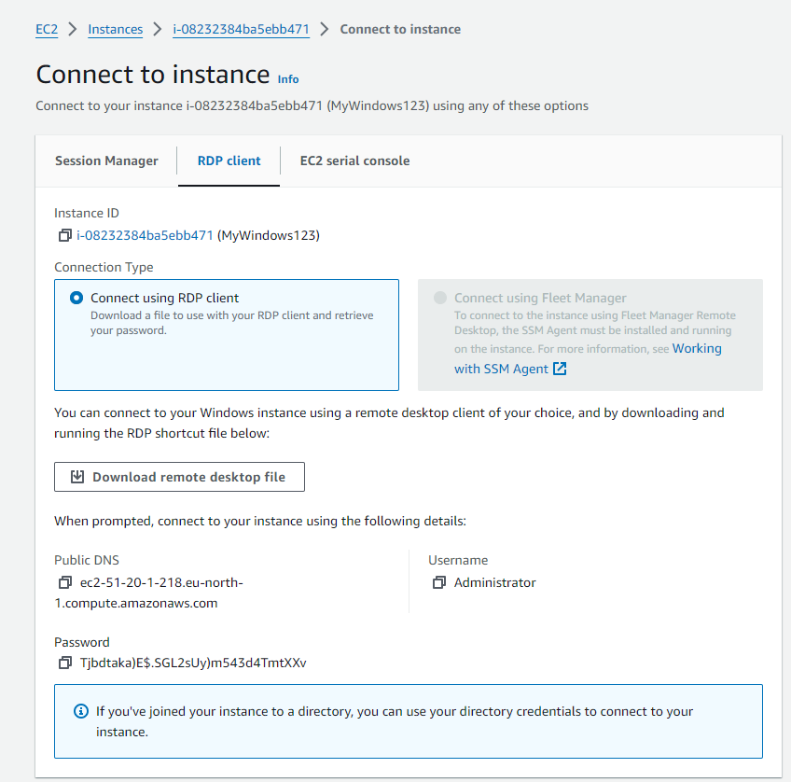

After clicking on get password, upload your private key file that you created and click on decrypt password.

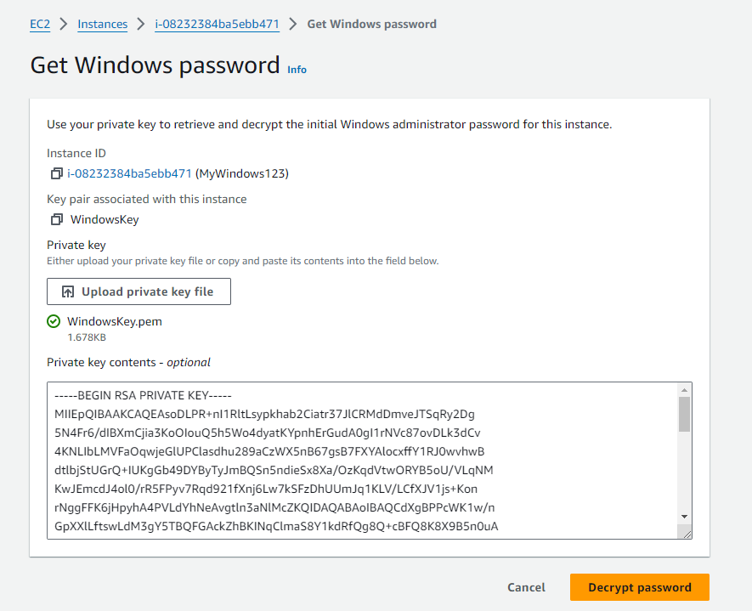

Now open the downloaded remote desktop file.

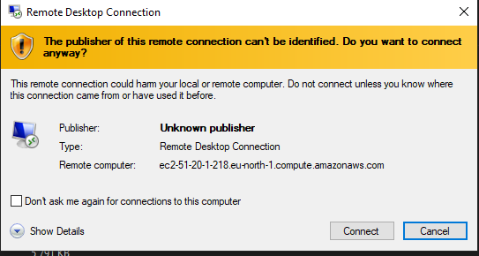

Enter the Password that you decrypted.

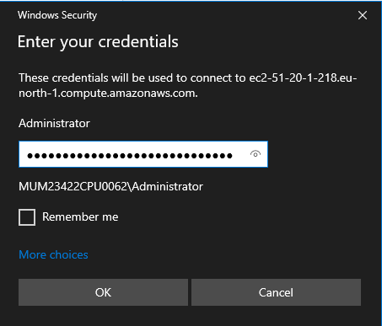

Now you’ll be able to see a Windows OS as follows which is a Virtual Machine

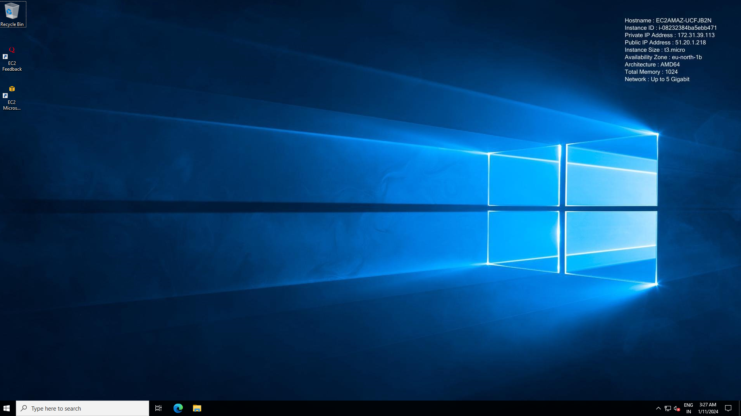

Now install python in that machine and run it in the Command Prompt

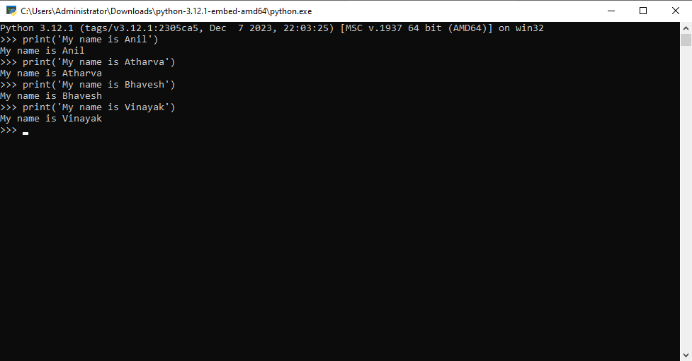

After this Terminate the Instance that you created.

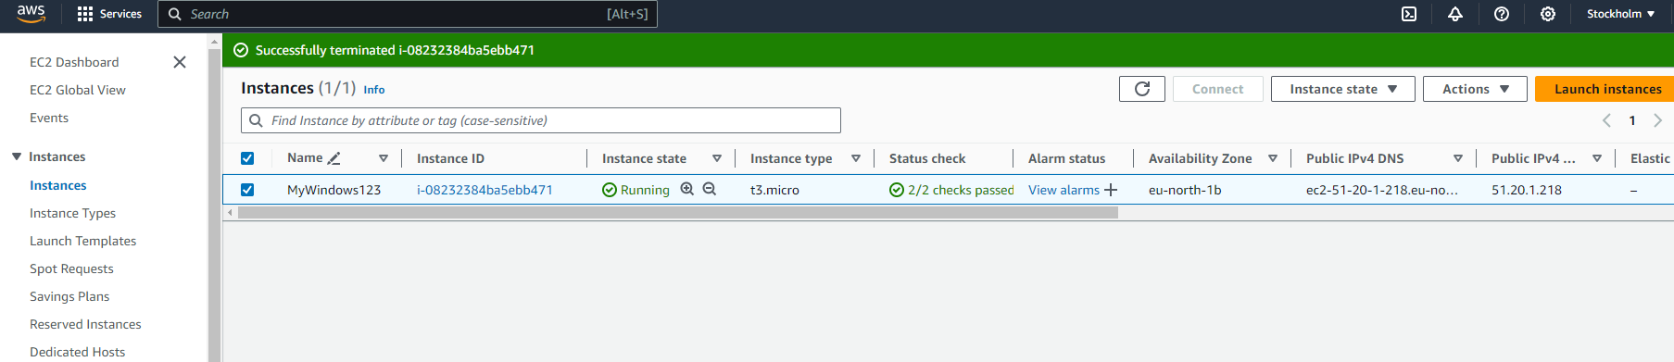

1. **Implement the Ubuntu Machine using AWS EC2 and Execute the Linux Commands**

* **Disk Information in Human Readable form**
* **Create a file with your name**
* **Create a file with you CourseName and add a text file in it**
* **Display the created file**
* **Copy the contents of the created file in another file and print it.**
* **Install Chrome Browser/ Python3**

**Step 1:** Create an EC2 instance

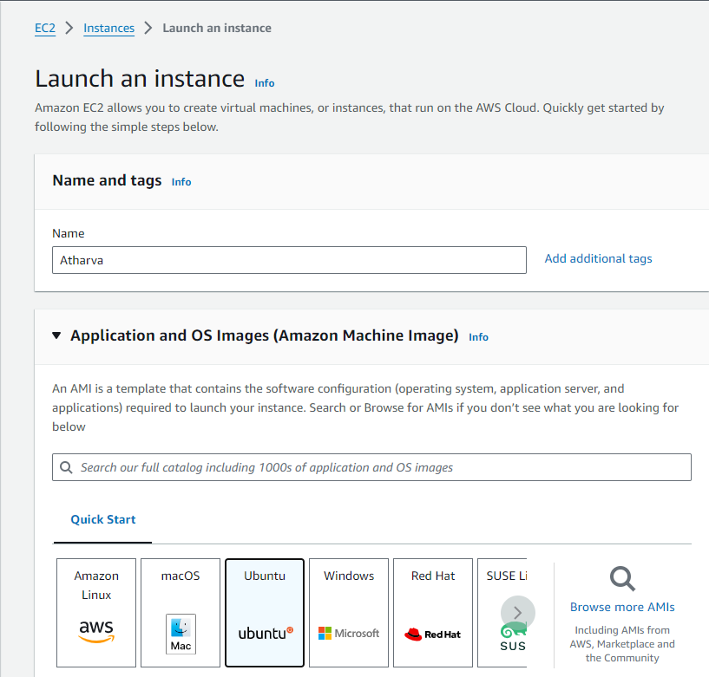

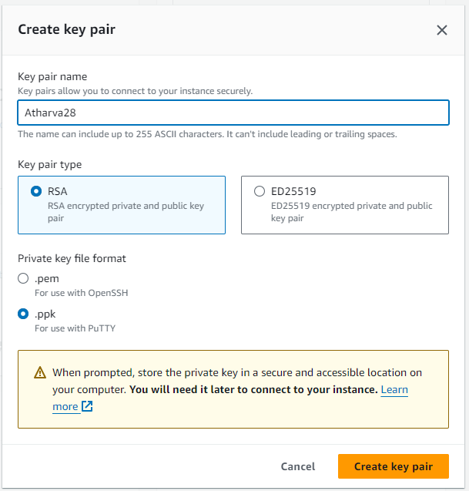

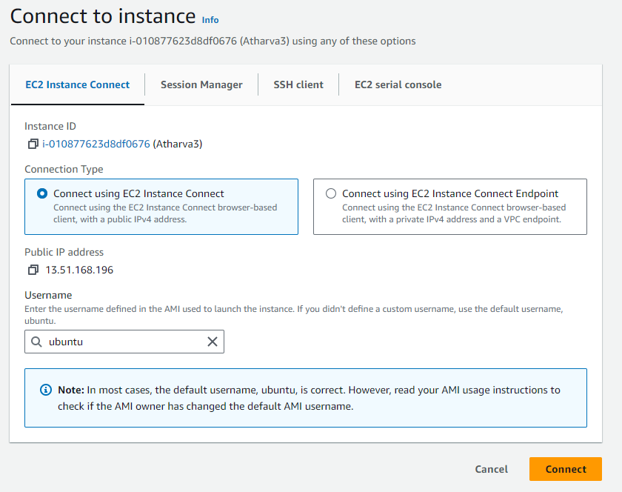

**Step 2:** After the instance is created open putty.exe file that we have downloaded

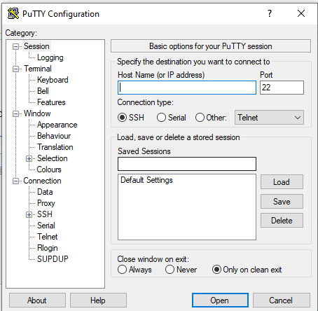

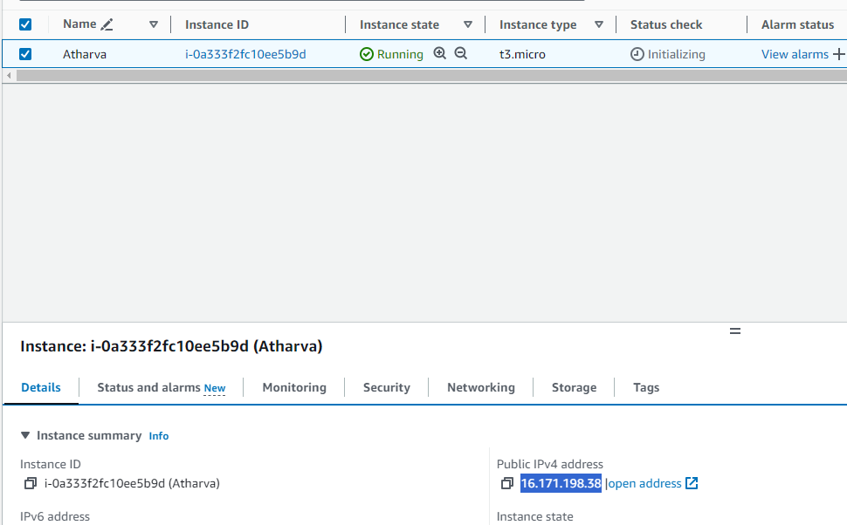

Put this IPv4 address in putty.exe

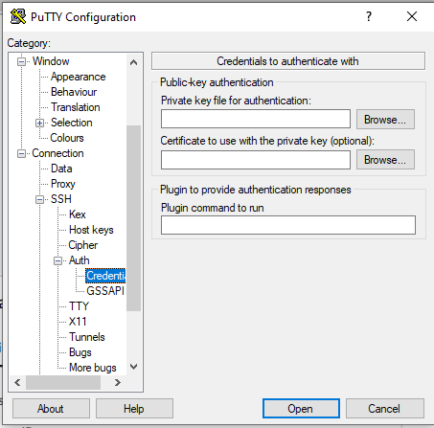

Select browse from here

**Step 3** Browse the ppk file you have downloaded

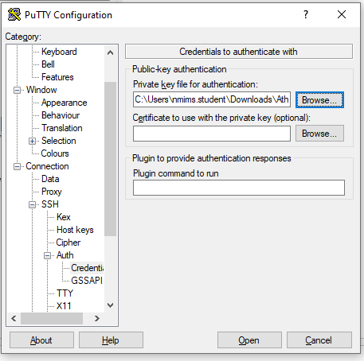

**Step 4:** Now a command prompt will be opened type your user name here

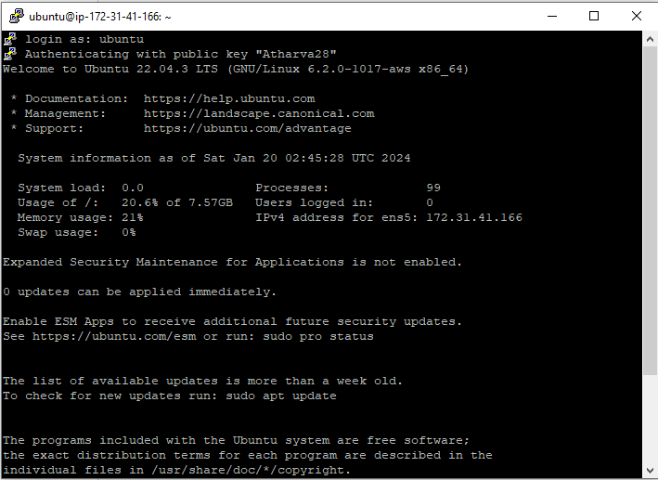

**Step 5:** Now enter the commands here

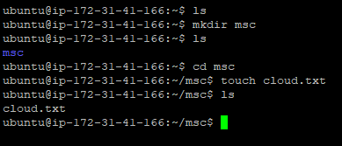

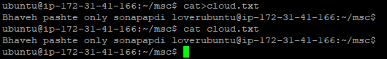

**Step 6:** Now install python in cmd



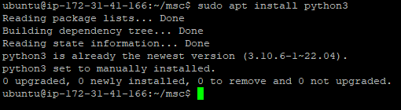

Because the python was already installed

**Step 7:** Now type python3 and then you can run python code on it

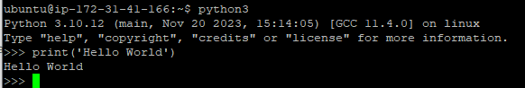

**Step 8** Create a file write your address and read the file

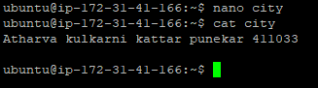

**Step 9:** Copy content from 1 file to another

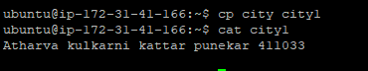

**Step 10:** install chrome browser in ubuntu

